# DETAILED CASE STUDY KAZAKHSTAN PUBLIC PROCUREMENT REPORTING MODULE

## Big data and data analytics

### Open Contracting Data Standard Transformation and Analytics

|  |  |  |  |
| --- | --- | --- | --- |
|  | **Lead Organisation**: Ministry of Finance;  European Bank for Reconstruction and Development (EBRD) |  | **Location:** Kazakhstan |
|  | **Problem Statement:** Kazakhstan has an **eProcurement system**; however, **information generated through it and stored was not structured using standards**, making analysis challenging and hindering data-driven decision making. The **complexity of architecture and the data organization** of the eProcurement system led to issues with data processing and querying. Also, the approach to public procurement reporting was not automated and was neither efficient nor reliable. | | |
|  | **Description:** Data is extracted from the existing electronic public procurement system, which continues to operate; and **transformed into the Open Contracting Data Standard (OCDS)** and published. A **business intelligence module** is run on top of it, accessing the data via an Application Programme Interface (API). This analytical module provides government procurement policymakers with **a tool to analyse and visualise procurement trends**. | | |
|  | **Lessons learnt: 1.** **The complexity of the system architecture, data organisation, processes conducted** – will drive costs up, and require more effort as well as knowledge to map data and set up the business intelligence tools; **2**. **Projects should be designed in several phases**, giving time for the government to make changes on the basis of the initial business intelligence tools developed; **3.** To ensure take-up and proper use of the developed tools, a **budget for training and outreach** should be included. | | |
|  | **Cost: €190 000** (main factors impacting cost of equivalent projects are the amount of extracted original data and eProcurement system complexity) |  | **Impact**: Enables public procurement policy makers to take **data-driven decisions**; Provides for the automated generation of public procurement reports; |
|  | **Human resources:** Project implemented by **EBRD and 2 IT/consulting contractors**, providing expertise in business intelligence software, ETL software development, and data analysis, mapping as well as modelling. |  | **Risks:** Gaining adequate **access to public procurement data and systems** required for the project, together with the expertise to understand these systems. Potential for political blocks to the project. |
|  | **Other requirements:** The project requires local expertise to understand processes and legislation in public procurement sector, and to ensure completeness as well as correctness **of retrieved and** transformed data. | | |
|  | **Project timeline**: Jul 2018 – Jun 2019 |  | **Project status:** Fully deployed |
|  | **Email:** NiewiadE@ebrd.com |  | **Website:** [EBRD – Public Procurement Reporting Module for the National eProcurement System](https://www.ebrd.com/cs/Satellite?c=Content&cid=1395267703431&d=Mobile&pagename=EBRD%2FContent%2FContentLayout) |

#### Context and problem statement

In 2017, the Ministry of Finance of the Republic of Kazakhstan sent a request letter to the EBRD related to the changes needed to be introduced to the country's public procurement system to negotiate accession to WTO GPA. The request specifically referred to the need to better understand the functioning of the electronic procurement system in Ukraine. Ukraine has a well-functioning electronic procurement system, and, benefiting from the Bank's assistance, developed a set of tools and practices for monitoring and reporting on public procurement. To address this request, the EBRD Legal Transition Programme (LTP) experts designed a new assignment under the auspices of the EBRD GPA TC Facility (the "Assignment") to assist the government with the development of a public procurement reporting tool for the national electronic procurement system (the "eProcurement System").

The problems identified in Kazakhstan during the project inception stage were as follows:

* There wasn't an automated workflow management capability accessible to all public procurement process stakeholders.
* Information regarding procurement procedures and public contracts, while stored electronically, was very difficult to retrieve.
* Stored public procurement data was unstructured and this made it difficult to deliver reliable and accurate research results;
* The transactional data was unavailable for analysis;
* The approach used for reporting was considered inefficient, unreliable, time-consuming, and hard to verify.

#### Objectives and vision

Working with the EBRD GPA Technical Cooperation Facility, the Ministry of Finance decided to modernise its public procurement system, ensuring it can draw on the data stored within its national electronic procurement system to drive improved public procurement policies and decisions. It aimed to:

* Provide improved public procurement statistics to guide decision making;
* Generate automated public procurement reports;
* Introduce Open Contracting Data Standard-based online reporting tool for the public procurement to the Government of Kazakhstan.

The EBRD-developed vision to achieve these objectives contains two primary points:

* Implementation of an open contracting data standard (OCDS) transformation on existing eProcurement data;
* Deployment of an OCDS-based set of business intelligence and reporting tools to enable an analysis of public procurement data.

#### Technological solution and implementation

The solution **extracts data from the existing electronic procurement system and converts it to the OCDS standard** while allowing the electronic procurement system to continue running its processes. Once the data has been converted to the OCDS and published, **the reporting module** for public authorities has been set up, which **access this data directly through** **an API**. The public procurement **reporting module allows users to analyse the electronic procurement data** and view the data through several different angles and filters. The overall result is the business intelligence tool to dig into and analyse the contract data.

##### Data extraction and transformation

The data is extracted in the following ways:

* Directly from the eProcurement system
* Middleware is used to extract this data, convert it to the OCDS and store it in a consolidated database. This process is shown in Figure 1.

Figure 1: OCDS Transformation and Analytics

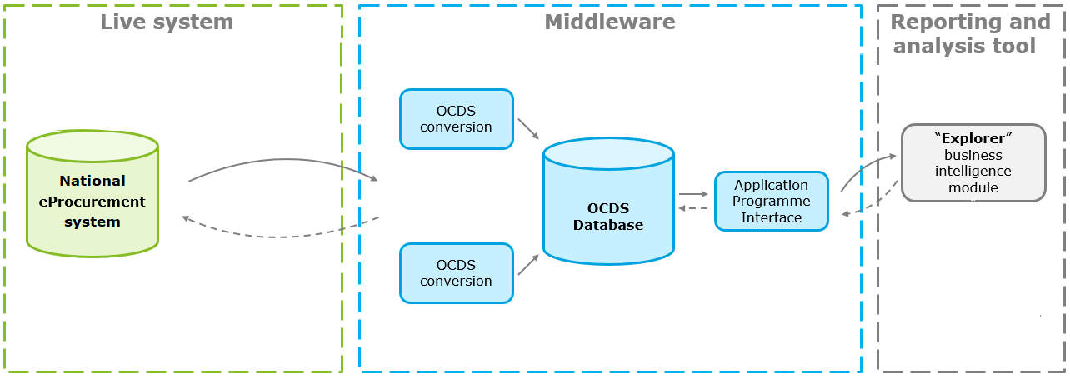

**Development of the data extraction and transformation solution**

The process of developing this data extraction and transformation system has a number of steps. First, there is a systems exploration stage. During this stage, the project team describes the processes by which the eProcurement system operates, it conducts technical analysis of these business processes and models them using business process modelling notation. Following this, an analysis of the system database is conducted in order to understand how it operates, to assess the quality and consistency of the data, and to judge how best to extract the data. Following this, business analysis is conducted in order to map the data in the database onto the OCDS standard. Once these analytical phases were complete, the project team developed an API through which the data is extracted from the live eProcurement systems and another API through which the data is made available for the business intelligence tool.

##### Data analytics tool

The data analytics tool provides a pre-defined set of dashboards which provide different analytical angles through which the OCDS data can be viewed. These dashboards provide a breakdown between different stages, processes and markets. Aspects such as the number of complaints and challenges, purchases made by a particular public entity, or the number of successful procurement procedures completed can be measured.

The data to be examined at different levels of detail, ranging from an overview of the functioning of the procurement system to data on individual public procurers or tenderers. Drawing on these dashboards, the data analytics tool - "Explorer" has been provided. The "Explorer" is built for public procurement analysts within the Ministry of Finance as well as other public administrations and is intended to support their decision-making.

Figure 2: Data analytics and transparency tools

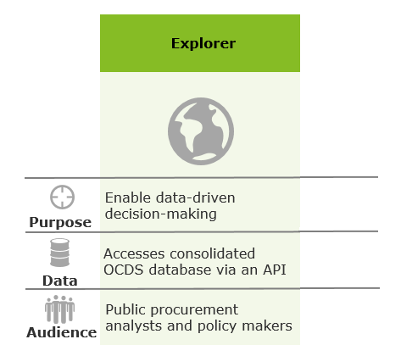

**Development of the data analytics tool**

The Ministry makes use of Qlik Business Intelligence software in order to view the "Explorer" data. The standard set of dashboards provided by the EBRD was tailored according to the needs of the Ministry of Finance and according to the nature and quality of the data available. The Ministry is able to further develop its own aspects to measure and visualise according to their priorities. Using the "Explorer" tool, automated reports on public procurement in Kazakhstan can also be generated.

The EBRD provided support to the public authorities for the development of the business intelligence tool. This includes not just technical support in relation to the digital tools being used, but support regarding the methodologies to use to calculate the measures of the various procurement procedures. This was done to ensure the proper alignment of the procurement processes followed and the indicators used to measure them.

#### Results and future expectations

As a result of the project, Kazakhstan now has a national-level public procurement data analytical infrastructure. This system enables a previously impossible level of vision over procurement spending within the country, and enables various types of big data analysis. In terms of the goals set for the project, the OCDS-based analytical system:

Enables the automated generation of public procurement reports – through the "Explorer" analytical tool. Provides support for public administration regarding public procurement decisions – Government employees are able to use the "Explorer" tool to analyse public procurement data and guide their procurement decisions.

Going forward, the impact of the project could be increased by allocating resources and budget to training and outreach programmes to promote the use of the business intelligence tool not just within the Ministry of Finance, but in agencies and departments across the Government. The tools and spending data now available could be used to guide decision-making not just for public procurement specialists but for policymakers across different policy fields. Also, it is important to encourage the government to provide access to public procurement data for the public at large.

#### Costs and requirements

Figure 3 Costs and requirements

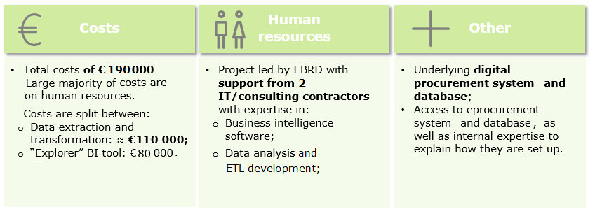

The OCDS data transformation and analytical solution was developed for a total cost of **€190 000**. The large majority of these costs are focussed on the human resources required to first analyse the existing processes and systems, and then develop the tailored data extraction, transformation, and analytical tools needed. Any licenses that are required, are relatively cheap.

The **breakdown of costs** is approximately as follows:

* **Development of data extraction and transformation** – roughly **€110 000**. The main variables affecting this cost are related to the quality of the underlying eProcurement system and databases. For this case an additional cost was incurred due to the complexity of the eProcurement system.
* **Development of the "Explorer" Business intelligence tool** – **€80 000**. The main factors influencing the cost are the underlying quality of the data, and the number of dashboards to be developed and market topics covered.

In terms of the **human resources required for the project**, the EBRD worked **with 2 separate consulting and technology firms** in order to develop the system. Each of these firms provided expertise in different areas, with one with specialist knowledge on the use of **Qlik and business intelligence software**, and the other with expertise in **data analysis, modelling, ETL software development**.

Other key requirements to perform the project include the **existence of digital procurement systems** in the first place. However, similar projects can be performed with a wide variety of different types and standards of such eProcurement system. As mentioned in the costs section above, however, a system with complex architecture and data organisation will require considerably more time and expense in order to perform the necessary data transformation and set up of functioning data analytics tools. A final key requirement in order to deliver such a project is to **have access to people and experts who can explain how the existing databases are set up and what the various data refer to**.

#### Risk and mitigation

At the start of the project, one of the risks identified relates directly to the point above – **access to the experts who could accurately describe the current state of the existing eProcurement system** and database. It was not known whether this would be provided, or whether for example the team risked being provided out-of-data or irrelevant information on the system.

Another major risk faced by the project concerned gaining **access to the eProcurement system and data** that was required. There was a risk of political blocks, with the eProcurement system operator refusing to cooperate with the project. This risk did partially materialise, with the E-finance centre refusing to provide automated update of the developed solution by the data from the eProcurement system and to open the OCDS API for the public use.

#### Challenges and lessons learnt

The main challenges for the project were related to getting the **necessary support from the people and organisations** in order to access the necessary systems and data. The assessment of the legacy system and data transformation is the most challenging phase, and the completion of this task requires internal support and expertise regarding procurement processes and data.

Lessons that can be taken from the project include:

* **The complexity of the system architecture, data organisation, processes conducted** –will drive costs up, and require more effort as well as knowledge to map data and set up the business intelligence tools developed.
* **Plan the project in several phases, providing time for feedback from the Government** –Following the initial development of the business intelligence tools, the Ministry decided to change a set of dashboards to cover additional topics which were not in the scope in the beginning. These changes affected data modelling, meant the business intelligence tools had to be themselves updated.
* **Budget for training and outreach should be included** – in order to ensure the new tools are understood and used.